Average Time Spent per Platform

Average Time spent on Social Media per Gender

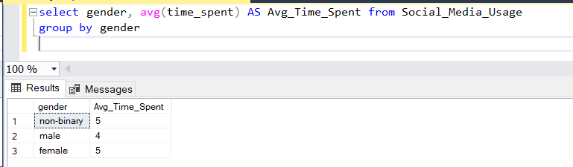

Average Time Spent per Demographics

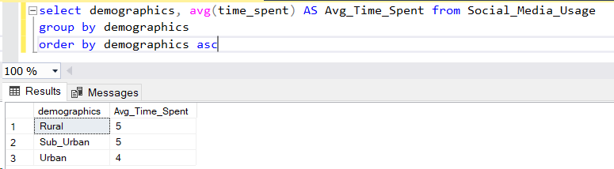

The most interesting activity

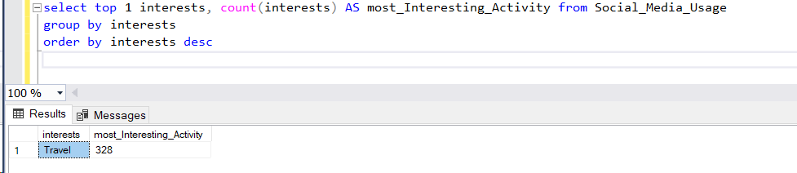

Highest and least time spent in the social media

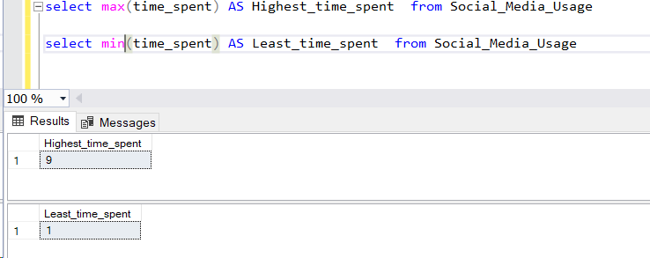

Most Popular Platform

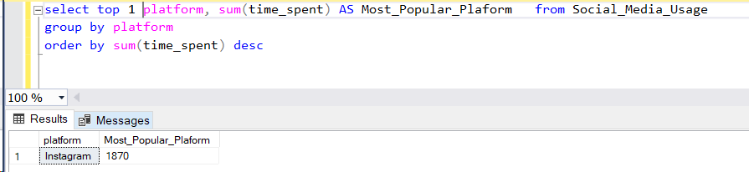

Popular platform Per location

